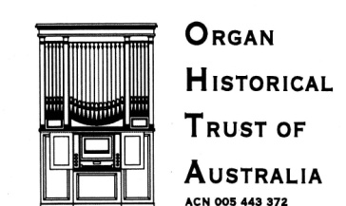

PO BOX 200 CAMBERWELL VICTORIA 3124

40TH ANNIVERSARY CONFERENCE 25- 30 SEPTEMBER 2017

Date [late August]

Dear …….

I am writing to confirm arrangements the visit of the Organ Historical Trust of Australia to [venue] on [date] September, between [time] and [time].

The visit is part of OHTA’s [40th Anniversary] conference. There will be more around 60 people attending from around Australia and New Zealand.

The organ will be demonstrated by one of our participants and there will also be time for others to play. The organ demonstration will be followed by a Lecture (30 minutes) “Title… ” to be presented by [name]. ]

We would like to confirm the following specific arrangements:

• Opening of the [venue] 15 minutes before we arrive,
• Closure of the [venue] after we depart,
• Access to the organ
• Availability of your public address system,
• Access to toilets
• Use of lighting

[We are wondering whether the Lecture can be presented in the church, using your data projector and screen. If the lecture needs to be presented in a location other than the church, we will be able to provide our own data projector and screen, but it would be most convenient if everything could take place in the one location.]

Can you please let me know whether this is possible?

I would be happy to visit [venue] in the next couple of weeks to try out the equipment if necessary.

The Organ Historical Trust of Australia will be pleased to make a donation for the visit and also to provide a copy of the conference book for your archives.

If you were available to welcome the group briefly, that would be excellent.

Kind regards,

(On behalf of the Conference Planning Committee)

(Please reply to ……)

